**SOFTWARE REQUIREMENT SPECIFICATION**

**1. INTRODUCTION**

1.1 Purpose

The purpose of this document is to build an online system to manage the employee details and to display the payroll slip of the employees.

1.2 Motivation

All the details of employee such as employee id, name, address, salary including allowances and deductions etc. are being done manually at the moment which is a time consuming task. Hence, a system is required that can perform all above said operations automatically. Moreover, the system should be user friendly, flexible, fast and highly secure.

**2. REQUIREMENTS**

2.1 Functional Requirements

2.1.1 Administrator

This module helps the administrator to enter the details of the particular employees in the organization and the related description. It also helps to add and modify the salary structure and attendance structure.

2.1.2 Employee

This module helps the employee to view their personal details and payroll slip.

2.1.3 Search

This module helps to search the employee details according to the employee id.

2.1.4 Salary

This module helps to calculate the salary by adding the allowances and the basic salary and by deducting the deductions based on the leaves and also the PF, PT. It also helps to generate the employee pay slip.

2.1.5 Report

This module helps to generate the employee reports like the Salary Report, attendance Report and the report including personal details.

2.2 Non Functional Requirements

The system must be developed to suit the particular needs of a user-friendly environment. This means that the system must accommodate a clearly understandable user interface as well as clear online help documentation at any stage of the user interaction with the system. A fast response time in obtaining and providing information to the system may also prove to be a significant advantage.

**Security:** Each user is required to log in. The system should log admin that has been assigned user names and passwords. The system should be designed to make it impossible for anybody to login without a valid username and password. Data encryption should be employed to keep the user login name and password secret.

**Performance:** The system should have a quick response time.

**Availability**: This system is designed to run 24/7 and be readily available to the user.

2.2 Software requirements

Compiler: Codeblocks (gcc complier)

Operating System: Linux, Windows 10

2.3 Waterfall model

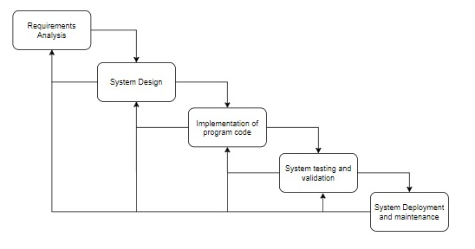

**3. DESIGN AND IMPLEMENTATION**

3.1 Product Features

* Complete and straightforward access info, update payroll info and generate management reports on demand.
* Accuracy- All the calculations are done mechanically, therefore, can avoid the human errors concerned.

Product backlog:

In [Agile development](https://www.bing.com/search?q=Agile+Software+Development&filters=sid%3a94d1d3c7-02c0-d529-1322-3f8bc06d8f4e&form=ENTLNK), a product backlog is a **prioritized list of deliverables** (such as new features) that should be implemented as part of a project or product development. It's a decision-making artifact that helps you estimate, refine, and prioritize everything you might sometime in the future want to complete.

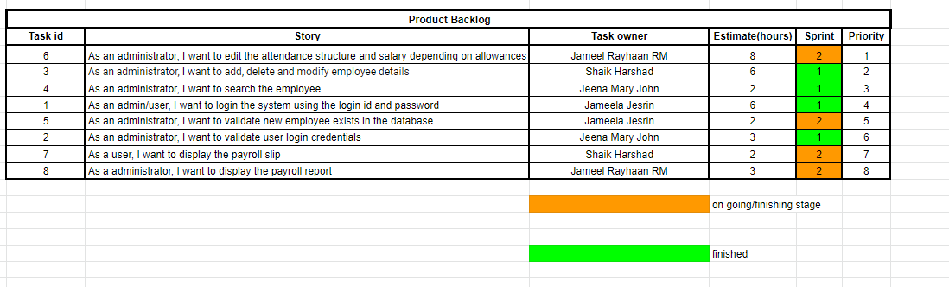

3.2 Use case diagram

The use case diagram are usually referred to as behaviour diagram used to describe the actions of all user in a system. All user describe in use case are actors and the functionality as action of system. The Use case diagram is a collection of diagram and text together that make action on goal of a process.

In this Employee Payroll Management system website project there are two actors can do all the activities to run the system. Admin, and Employee.

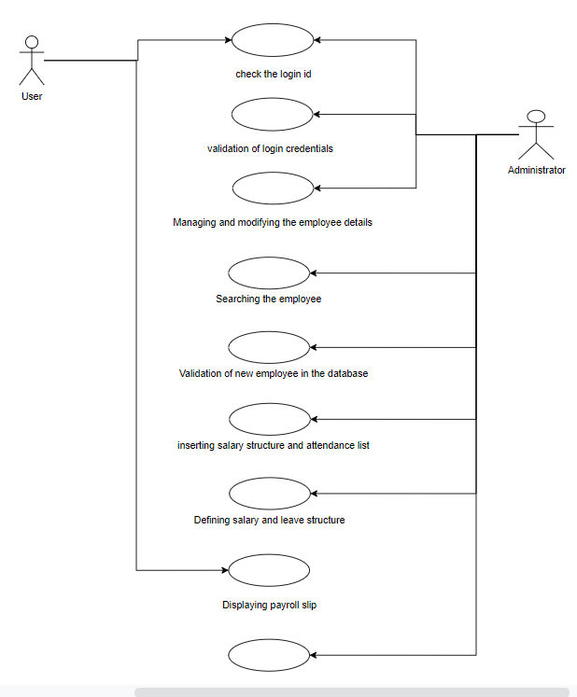

3.3 UML Sequence Diagram

The diagram below helps demonstrate how the login page works in a Payroll Management System. The various objects in the working points, employee, salary, attendance, and appraisals page interact over the course of the activity, and user will not be able to access this page without verifying their identity.

